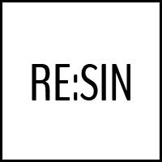
RETURNED GOODS FORM
RETURNING OF NON CONFORMING OR DEFECTIVE GOODS

YOUR PERSONAL DETAILS

Name and
surname
Address
Phone number
E-mail address

YOUR ORDER INFORMATION
Order number
Date of order
Returned goods | Detailed description of the defect/non- conformity

Date: _______________ Signature: _______________
Important: Please note that any non-conformities or defects detected on the purchased goods must be reported within the terms indicated on the Sales Conditions you accepted on making your purchase; the same also indicate the rights you are entitled to concerning the ascertaining of non-conformities or defects.

